A000-Asia-China-Qijia-Disc-3 Notch-Jade-3.2 in-2200 BCE

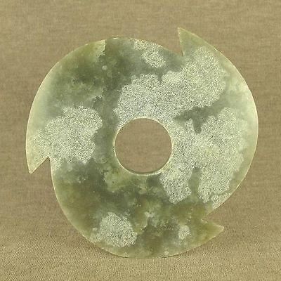 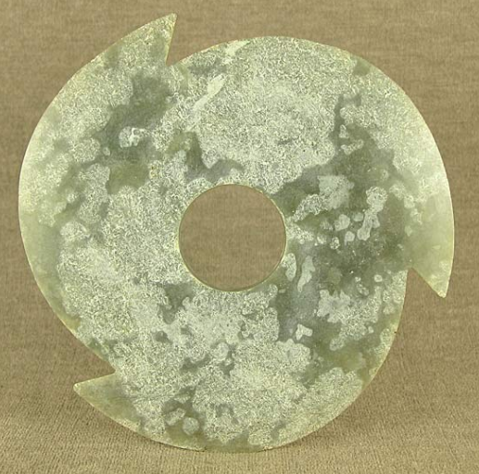

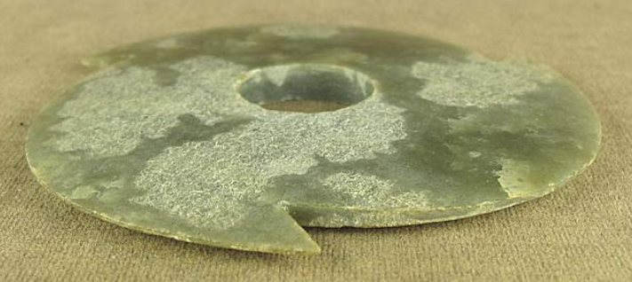

Figs. 1-3. Asia-China-Qijia-Disc-3 Notch-Jade-3.2 in-2200 BCE

**Case no.: 5**

**Accession Number:**

**Formal Label:** Asia-China-Qijia-Disc-3 Notch-Jade-3.2 in-2200 BCE

**Display Description:**

This Qijia Culture 齊家文化 Three-Notched Jade Disc ( Hsuan Chi ) dates approximately to the beginning of the Late Neolithic Xia Period,.2200 BCE. It is composed of silicates (antigorite, oltrelite, with iron schists), which provides a celadon green color. It has 3 notches without additional serrations, and its two sides are planar without any engravings. Its central hole is drilled from only one side. The notches may relate to the three major asterisms of the Little Dipper: Polaris, Alpha Ursae Minoris (alpha Mi) and, Kochab (beta UMi), and Pherkad (gamma UMi).



Fig. 4. The three major asterisms of the Little Dipper as they appear in the Southern Hemisphere after <https://www.space.com/28048-little-dipper.html>

**LC Classification:** NK5750.2.C6

**Date or Time Horizon:** 2200–1600 BCE

**Geographical Area:** Western Huang Ho region

**Map:**

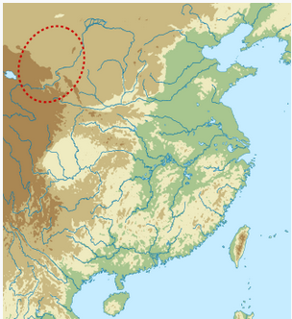

**Fig. 5.** Location of the Qijia Culture after https://upload.wikimedia.org/wikipedia/commons/thumb/a/ac/Qijia_map.svg/330px**-Qijia_map.svg.png**

**GPS coordinates:**

**Cultural Affiliation:** Qijia

**Medium:** green jade with some calcification

**Dimensions:** D 3.2 in, T 0.15 in

**Weight:**

**Condition: original.**

**Provenance:**

**Discussion: after Wikipedia.**

The Qijia Bronze Age Culture (2200–1600 BCE), was identified in 1923 by the Swedish archaeologist Johan Gunnar Andersson (1874–1960) in sites along the Tao River in Gansu province, but only in 1924 was it named after a site at Qijiaping, Guanghe county, Gansu. The jade artifacts from this culture are characterized by two major forms: the Bi or the Circular Disc that can also be notched and the Cong with its square, unadorned or ridged outer surface and hollow cylindrical inner core. Qijia jade Bi and Cong are mostly unadorned without engraved or modeled motifs. The two basic geometric forms of the Bi and Cong are the circle and the square, which, in associated cultures, especially the Majiayao that developed iconographies for Heaven and Earth. The Majiayao culture represents the first time that the Upper Yellow River region was widely occupied by agricultural communities. It is famous for its black on red painted pottery, which is regarded as a peak of pottery manufacturing at that time. The Qijia Culture emerged where the Majiayao Culture vanished in 2200 BCE. Probably the same groups of Neolithic communities on the upper Yellow River region (E Gansu, E Qinghai and N Sichuan) emerged between 3300 and 2000 BCE possibly with some iconographic continuity of the two cultures, the Majiayao and the Qijia.

**References:**

Chen, Honghai. 2013. "The Qijia culture in the upper Yellow River valley". In Underhill, Anne P. A Companion to Chinese Archaeology. London: Blackwell, pp. 105–124.

Cullen, Christopher and Anne S. L. Farrer. “On the Term "Hsüan Chi" and the Flanged Trilobate Jade Discs,”1983. *Bulletin of the School of Oriental and African Studies, University of London*, 46(1): 52-76.

Gu, Fang and Childs-Johnson, Elizabeth. 2008. *Jades of the Qijia and related northwestern cultures of early China, ca. 2100-1600 BCE* [project coordinator Jessica Curnoe]. New York: Throckmorton Fine Art